**George Brown College**

**Centre for Arts, Design and Information Technology**

**Machine Learning Process – Working on a CSV file (Assignment 01)**

The goal of this assignment is to practice working with csv files and using NumPy functions.

Please follow the following steps using the Jupyter Notebook or any other environment to implement steps. At the end you need to submit all the codes in a word document into Assignment 01 folder.

Please note that this is an individual assignment. You can help your team members to understand the problem statement, but everyone needs to do the assignment individually and submit their tasks individually.

Moreover, as there are 5 different versions of assignment 01 (Assignment 01-a, Assignment 01-b, Assignment 01-c, Assignment 01-d, Assignment 01-e) everyone in a group needs to pick a different version.

The individual submission is mandatory, while everyone will open and run their assignments in the class to demonstrate what they have learned from it.

The due for the first assignment is October 4th, 2019, 11:55 PM. You will present your assignment in a lab session after October 4th, based on your lab section.

**Let’s start the assignment:**

1. Write your name and relevant info in the first cell as follow: 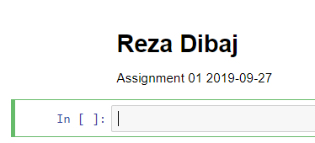
2. Import the **grades.csv** file and place it in an appropriate dataset. (2 points)
3. Fetch the **Final** column of the dataset and use a variable to hold this array. (1 points)
4. Print the content of the **Final** column. (1 points)
5. Calculate the average, standard deviation, minimum and maximum of the array and print the result. (2 points)
6. Find the 30th percentile, median and 70th percentile of the **Final** column. (2 points)
7. Using the Matplotlib library, please draw a histogram chart for the **Final** column. Please use appropriate title, X-label and Y-label, and include your first name in the title, e.g. ‘**Final Distribution – By Reza**’. (2 points)

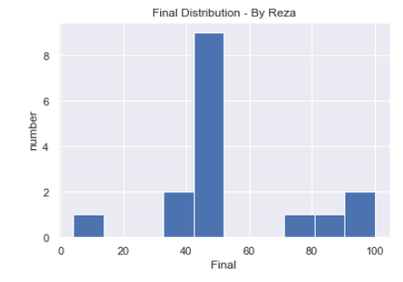

Thank you and good luck,

Reza

You are not a drop in the ocean. You are the entire ocean, in a drop. ~Rumi